SECTION HD

AIR SHUTDOWN VALVE

CONTENTS

|  |  |
| --- | --- |
|  | chapter |
| Description .. | 1 |
| Servicing | 2 |

CHAPTER 1

DESCRIPTION

1. The air shutdown valve (Fig HD.l) is incorporated in the air trunking between the turbocharger and the charge air heater/cooler. Its purpose is to provide a means of shutting off the air supply to the engine in the event of:-
2. Engine overspeed.
3. Emergency shutdown.
4. On receipt of a signal that gas is present (If sensing equipment is fitted).
5. The valve consists of shut-off valve (4) and dump valve (10), both operating on spindle (27) within housing (30), and valve cover (5) which provides a seating for the dump valve.
6. During normal running shut-off valve (4) is held open by plunger (15) acting as a stop against lever (14) and preventing rotation of spindle (27). Should any of the above circumstances occur, lubricating oil is released to the underside of plunger (15) causing it to move against the action of spring (34) and to free lever (14).
7. Spring (29) is now free to initiate shut-off valve closure, assisted by the weight of the valve itself. After 20° of free movement, flats on the shut-off valve contact flats on the dump valve opening it, allowing any additional air supplied by the turbocharger to be discharged to atmosphere.
8. When the engine has stopped, lubricating oil pressure decays and plunger (15) will return to its original position. The valve can then be reset by means of hand lever (12) until lever (14) is behind the plunger. After resetting check that the plunger is fully home.

CHAPTER 2

SERVICING

1. Release the lubricating, oil piping to the operating cylinder. Remove the electrical connections to the microswitch (25). Release and remove the valve as described in Section LC.

Dismantling

1. Check that the valve is fully open. Remove setbolts (9) and remove valve cover (5) complete with valves and operating cylinder from its dowel location with housing (30). Disengage and remove spring (29).
2. Remove setbolts (20) and separate operating cylinder (21) from its dowel location with valve cover (5). Remove setscrews (19) and remove end cover (18), together with plunger (15), withdrawing the plunger from the bore of the operating cylinder. DO NOT remove 'U' seal (33) except to renew. If it is necessary to renew spring (34), drive out Mills pin (35) and separate plunger (15) from end cover (18).
3. Remove locknut (28) and unscrew eyebolt (26). Place the valves at the most suitable position and drive out Mills pins (22) until it is possible to withdraw the spindle from the cover, after which both valves may be removed and separated, and Mills pins (22) removed completely.
4. DO NOT remove joint rings (3) or (11) except to renew.

Inspection

1. Check all mating faces for superficial damage which may impair sealing. Examine all threaded components for serviceability.
2. Examine joint rings (3) and (11) for security and damage. If it is necessary to renew either of these joints proceed as follows:-
3. Remove and discard the joint ring. Thoroughly clean the joint ring seating surface to remove all traces of old adhesive and to produce a deliberately roughened surface. Clean with 'Loctite Safety Solvent’ or 'Genklene' and allow to dry.
4. Apply Dow Corning Primer 1200 to the roughened surface and allow to air dry for 30 to 45 minutes at room temperature.

CAUTION PRIMER 1200 IS FLAMMABLE; KEEP AWAY FROM HEAT AND OPEN FLAME.

1. Apply Dow Corning Silastic 732 RTV adhesive to the prepared surface in a uniform thickness. Put the new joint ring in place applying enough pressure to displace air but not adhesive. Let the unit stand undisturbed at room temperature for 24 hours to cure.
2. Check springs (29) and (34) for distortion or collapse. When new the springs conform to the following

Tension spring Free length 100 mm (3.94 in) Rate 10.35 N/cm (5.89 lb/in)

Compression spring Free length 86.4 mm (2.95 in) Rate 0.483 N/mm

1. Examine plunger (15), 'U' seal (33) and 'O' ring (32). Renew as necessary.

Assembly

NOTE All joints and 'O' rings must be fitted dry.

1. Fit new 'O' rings (24) to spindle (27). Apply a little petroleum jelly to the spindle. Place the two valves together in position in the cover and insert the spindle taking care not to damage the 'O' rings.
2. Align the drillings in the shut-off valve and spindle and insert Mills pins (22) from the dump valve side of the assembly with the assembly with the shut-off valve in the fully shut position, ie at 90° to the cover. Carry out the following:-
3. Check that the dump valve moves freely on the spindle within the confines of the flats.
4. Check the end float of the dump valve in the shut-off valve. This should be between 0.015 and 0.035 in
5. Check the end float of the shut-off valve in the cover. This should be between 0.015 and 0.035 in.
6. Fit lever (14) and hand lever (12) if these have been removed and drive in the Mills pins. Screw in eyebolt (26) and fit locknut (28).
7. Assemble the components of plunger (15) using a new 'U' seal (33) and 'O' ring (32) if necessary. Lubricate and fit to the operating cylinder together with end cover (18). Fit plain washers and setscrews (19).
8. Check that dowel (37) is in position. Engage the operating cylinder with valve cover (5) and secure with plain washers and setbolts (20).
9. Turn knob (36) to present the flat on the plunger (15) to coincide with lever (14). Operate the shut-off valve to ensure a positive action between the plunger and lever. Check for 0.003 in clearance between the lever and the end of the plunger with the dump valve fully closed.
10. Using a new joint (1) and checking for dowel location, fit valve cover (5) and secure with plain washers (8) and setbolts (9). Operate the shut-off valve and check that the valve lands squarely on its seat. In service the valve closes with considerable force and no twisting stresses can be tolerated.
11. Fit cover (13) to valve cover (5) and secure with plain washers (6) and setscrews
12. .
13. Screw the eyebolt into valve cover and fit locknut. Engage spring (29).
14. Using new joints as appropriate fit the shutdown valve to the support bracket and into the air inlet piping as described in Section LC.
15. Connect the lubricating oil piping and remake the electrical connections to the remote warning microswitch. Check remote warning.
16. Slacken vent plug (16) and vent the operating cylinder in accordance with Section DA.

Key To Numbers

|  |  |  |  |
| --- | --- | --- | --- |
| 1. | Joint | 21. | Operating cylinder |
| 2. | Dowel | 22. | Mills pins |
| 3. | Joint ring | 23. | Tapped hole |
| 4. | Shut-off valve | 24. | 'O' ring |
| 5. | Valve cover | 25. | Microswitch |
| 6. | Plain washer | 26. | Eyebolt |
| 7. | Setscrew | 27. | Spindle |
| 8. | Plain washer | 28. | Locknut |
| 9. | Setbolt | 29. | Spring |
| 10. | Dump valve | 30. | Housing |
| 11. | Joint ring | 31. | Direction of air flow |
| 12. | Hand lever | 32. | 'O' ring |
| 13. | Cover | 33. | U seal |
| 14. | Lever | 34. | Spring |
| 15. | Plunger | 35. | Mills pin |
| 16. | Vent plug | 36. | Knob |
| 17. | Dowty washer | 37. | Dowel |
| 18. | End cover | 38. | Dowel |
| 19. | Setscrew | 39. | 'O' ring |
| 20. | Setbolt |  |  |

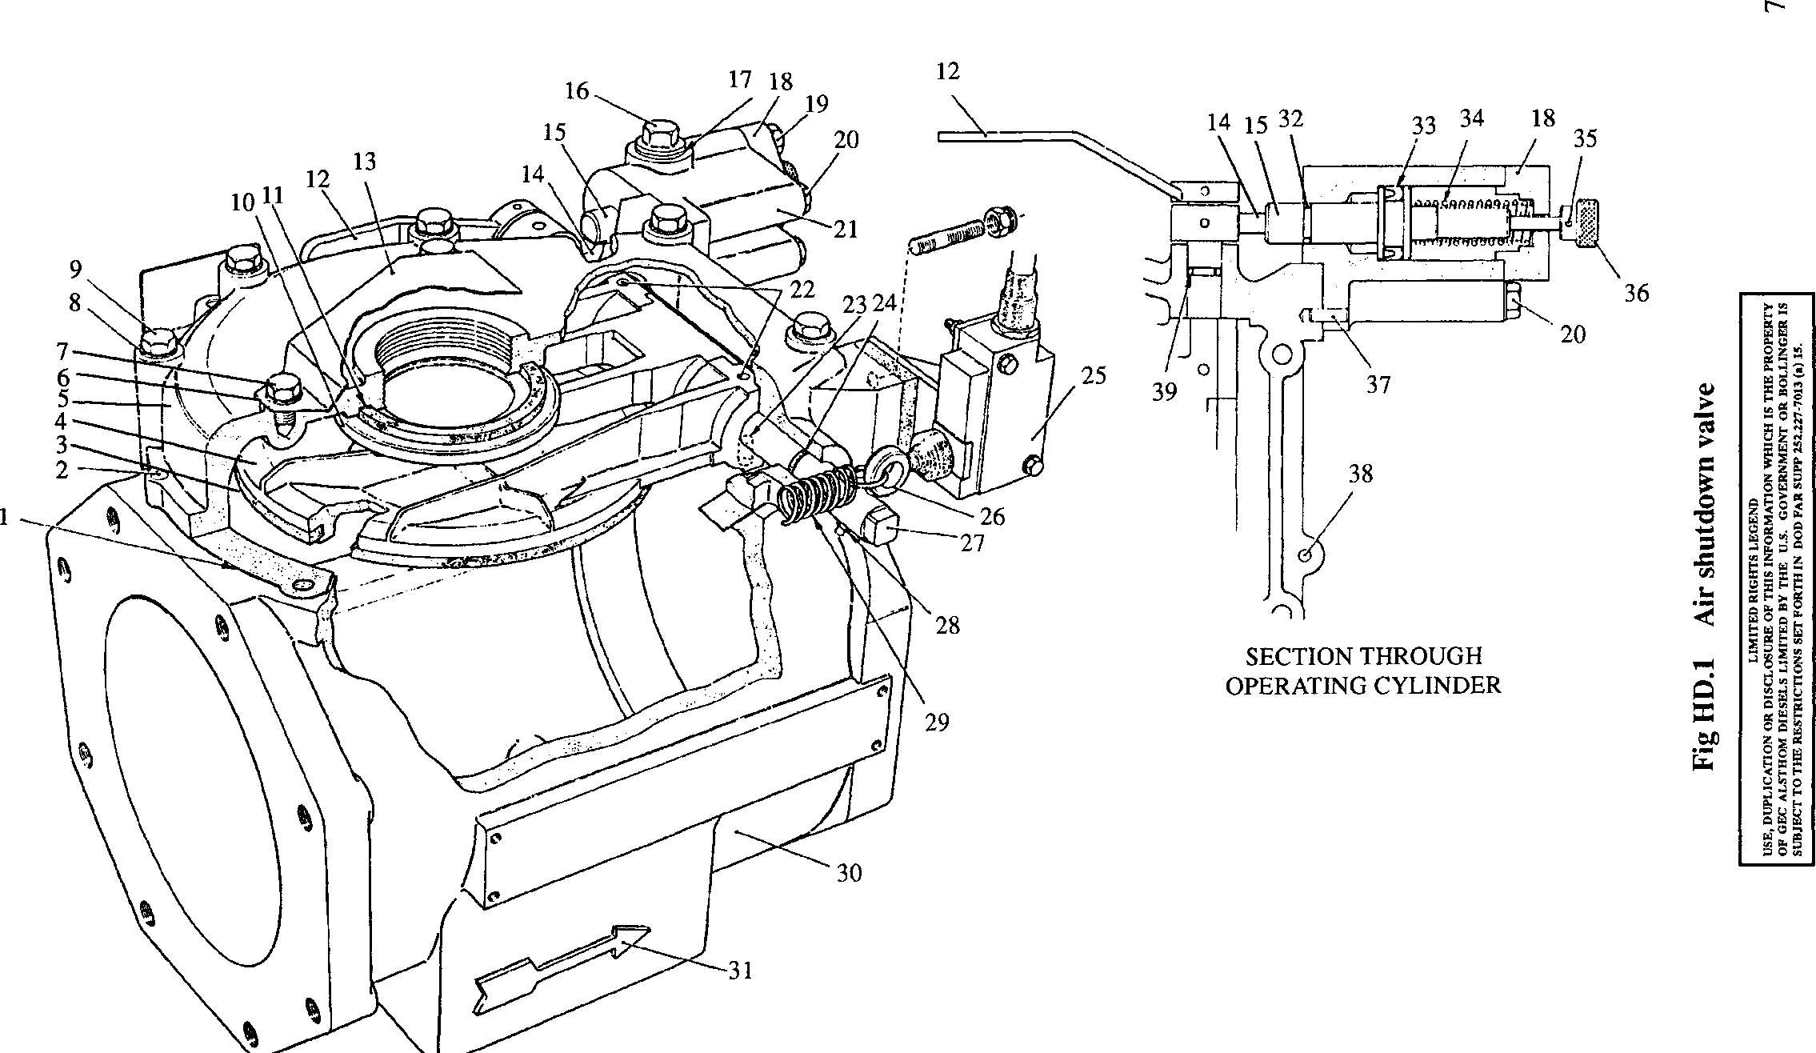

200HD030

SECTION HD

OVERSPEED TRIP UNIT AND DRIVE

CONTENTS

Chapter

Description and Operation .. .. .. .. .. .. .. 1

Servicing Overspeed Trip Unit .. .. .. .. .. .. 2

Servicing Overspeed Trip Unit Drive .. .. .. .. .. 3

CHAPTER 1

DESCRIPTION AND OPERATION

Overspeed Trip Unit (Fig HD.2)

1. The overspeed trip unit is of the centrifugal, mechanical/hydraulic type. Mounted at the drive-end of the engine, it is driven from the auxiliary drive train and supplied with oil for shutdown purposes from the engine circuit. It provides an automatic means of stopping the engine should the speed exceed the normal operating range by more than 10%.
2. To enable the mechanism to be tested, a secondary setting is also incorporated in the trip unit to provide engine shutdown at a speed BELOW the normal operating range.
3. The operating of the trip unit is controlled by speeder spring (40), the loading of which may be varied by adjusting screws (36) and (39). After initial setting these adjusting screws are locked together with nut (35) to form a single unit.
4. In normal operation, inner adjusting screw (39) is screwed down to give the correct loading on spring (40) for overspeed purposes.
5. When checking or testing the operation of the trip unit, outer adjusting screw (36) should be unscrewed as far as possible, ie. until collar (37) contacts the underside of cover (41). As the two adjusting screws are locked together, the inner will also be withdrawn, reducing the loading of spring (40) to allow the trip unit to operate at a speed below normal operating level.
6. In operation, passage of oil through the trip unit is barred by top land (51). As the tripping speed is approached, centrifugal force exerted on flyweights (42) will start to lift pilot valve (45) further loading spring (40) until at the set tripping speed the pilot valve has lifted sufficiently to allow oil to flow from inlet port (50), under top land (51) to outlet port (59). This pressure is communicated to feedback chamber (49) via drilling (52) in the pilot valve. The flyweight/spring system previously balanced, now becomes unbalanced due to the oil pressure under feedback land (48) and the pilot valve moves fully upwards so that oil flows freely through the trip unit.
7. From outlet port (59), oil is passed to block (15), past non-return valve (60) to the overspeed shutdown portion of the fuel limiter to return the fuel racks to the 'NO FUEL' position and stop the engine (Section HB). Oil is also passed via port (18) in indicator valve (21) to the underside of diaphragm (10) to lift indicator valve assembly, indicator stem (28) and indicator button (2) against the pressure of spring
8. to give visual indication of operation. Cone (27) mounted on the indicator stem and retained in position by locknut (26) will cause microswitches (7) to be operated as the rod is lifted and provide remote indication of overspeed.
9. As the engine slows to a stop, the force exerted by flyweights (42) will decrease and the oil pressure will fall until pilot valve (45) is closed by spring (40) and opens drain port (58). All oil pressure within the trip unit will be relieved except in the shutdown system where it will remain trapped by non-return valve (60).
10. To reset the system, depress indicator button (2) and hold for approximately 5 seconds. This action will move indicator valve (21) downwards to allow the oil port (18) to clear the bottom of valve housing (12) and the centre radial drilling to align with the block drain drilling (62), relieving all pressure in the shutdown system which will automatically reset itself. Oil in the block displaced by the downward movement of the indicator valve is passed to drain via non-return valve (16).

Overspeed Trip Unit Drive (Fig HD.l)

1. The resilient drive unit between the auxiliary drive gear train and the overspeed trip unit also forms the mounting for the overspeed trip unit.
2. The drive is transmitted via bevel gear (79) and drive shaft (81) to lower sleeve (74), then via spring (73) to upper sleeve (67). Bearing (72) between the sleeves absorbs all end thrust. The top end of the bore of upper sleeve (67) is splined to engage with the trip unit drive shaft.
3. In the event of collapse or failure of drive spring (73), drive dogs (88) provide a solid drive.
4. Shaft (81), thrust bearing (72) and the drive splines in upper sleeve (67) are lubricated from the trip unit supply.

CHAPTER 2

SERVICING OVERSPEED TRIP UNIT

Removal

1. Release capscrews and remove microswitch cover (65)(Fig HD.2).
2. Identify and mark wiring, disconnect from microswitches (7) and withdraw from cable gland (9).
3. Disconnect and remove lubricating oil inlet and delivery piping.
4. Release nuts (87)(Fig HD.l), remove washers (86) and lift trip unit off the drive unit. Remove joint (84) and 'O' ring (68).

Dismantling

1. Remove four capscrews (17)(Fig HD.2) and spring washers, and remove block (15) from body (54). Remove joint (61).
2. Release securing capscrews and spring washers, and remove microswitches (7), insulating leaf (6) and mounting bracket (8).
3. Release capscrews (24) and separate switch housing (25) complete with indicator valve from indicator block (15).
4. Release capscrews (11) and separate valve housing (12), complete with diaphragm from the switch housing.
5. Withdraw indicator valve complete with diaphragm from housing (12).

NOTE DO NOT separate component parts of indicator valve unless diaphragm renewal is necessary.

1. Unscrew and remove cap (3) complete with indicator stem assembly. Grip lower end of stem (28), unscrew domed head screw (1) and remove indicator button (2), and spring (4) from stem (28).

NOTE DO NOT alter position of cone (27) and locknut (26) or attempt to remove collar (29) unless renewal is necessary.

1. Unscrew plugs and withdraw springs and non-return valves (16) and (60).
2. Remove securing capscrews (66) and lift off top cover (41) and joint.

NOTE DO NOT break locking wire (34) or move adjusting screws (36) and (39) unless renewal is necessary. If the adjusting screws are not moved, trip setting should be within acceptable limits when the unit is re-assembled.

1. Should it be necessary to remove adjusting screws proceed as follows:-
2. Measure and record distance from joint face of top cover (41) to spring mounting face of adjusting screw (39).

Break and remove locking wire (34).

2.13.2

2.13.3

2.13.4

Release and remove nut (35) and its plain washer, and unscrew inner adjusting screw (39).

Remove circlip (38), collar (37) and unscrew outer adjusting screw (36).

2.13.5 DO NOT REMOVE locking wire peg (33).

1. Lift out speeder spring (40).
2. Release circlip (56), remove collar (57) and withdraw the rotor and flyweight assembly complete.
3. Remove a 'Twiclip' from each flyweight spindle (43), push out spindles and remove flyweights (42).
4. Grip top of pilot valve (45) or lower spring carrier (31) in suitable soft grips, remove nut (32), unscrew lower spring carrier and lift off thrust race (30).
5. Remove capscrews (64) securing flyweight carrier (46), lift carrier off locating dowels (47) and withdraw pilot valve (45) from rotor (53).

NOTE The metal of the carrier is peened over to lock capscrews (64) and it  
may be necessary to free capscrews with the aid of a drill.

Inspection

1. Thoroughly wash all parts in clean fuel oil or kerosene, carefully removing all traces of jointing from mating faces. Ensure that all oilways are clear with particular reference to jet (63).
2. Check speeder spring for distortion and corrosion.
3. Inspect pilot valve, rotor spindle and indicator valve and housing for scores and high spots. Check that when cleaned and lightly oiled, valves slide smoothly in their bores. If any stickiness of movement is apparent, valves should be withdrawn and checked for burrs and damage. If necessary, they may be lightly lapped to their bores using a lapping paste not coarser than 2A 700 WF, washed, oiled and retested.
4. Check flyweights for freedom of movement on their spindles and flyweight toes for flats. Check bushes (44), renew if worn.

NOTE Flyweights must always be renewed in pairs.

1. Check splined portion of rotor for fretting.
2. Examine thrust collar (57) for excessive wear and circlip (56) for serviceability.
3. Examine bore of cap (3) and indicator stem (28) for excessive wear.
4. Check diaphragm for pin holes, cracks or other signs of damage. If renewal is necessary proceed as follows:-
5. Grip upper end of centre bolt (22) in a soft jawed vice and remove locknut
6. .
7. Remove indicator valve (21), cap (23) and diaphragm (10).
8. Thoroughly degrease threaded portions of indicator valve (21), centre bolt (22) and locknut (14), using 'LOCTITE' SAFETY SOLVENT or TRICHLOROETHANE and allow to dry.
9. Mount centre bolt (22) in a soft jawed vice, threaded end uppermost and place diaphragm (10) over the stem, FABRIC SIDE DOWN, ie. fabric to cup and place valve cap (23) in position.
10. Apply 'LOCTITE 221' to centre bolt thread and screw on and tighten indicator valve (21). Fit and tighten locknut (14). Allow 'LOCTITE' to cure (See Section EB).

NOTE Care must be taken not to distort diaphragm when tightening indicator valve (21) and locknut (14).

1. Check non-return valve balls for damage and their springs for corrosion, distortion and collapse.
2. Examine all threaded components for serviceability.

Assembly

NOTE All joints and *O' rings must be fitted dry.

1. The following procedures are based on the assumption that the unit has been completely dismantled.
2. Insert pilot valve (45) into bore of rotor (53).
3. Pass flyweight carrier (46) over stem of pilot valve and engage with locating dowels (47). Secure carrier with capscrews (64) and lock by peening metal of carrier over the heads of capscrews with a centre punch.
4. Fit one 'Twiclip' to each flyweight spindle (43), place flyweights (42) in position in carrier, insert spindle and fit remaining 'Twiclips'.
5. Place thrust race (30) in position over pilot valve stem and in contact with flyweight toes, and screw on lower spring carrier (31). Adjust position of carrier so that when lower edge of pilot valve top land (51) just laps (closes) rotor oil inlet port (50), pilot valve still has a further maximum downward movement of 3/64 in (1.19 mm). This movement can be measured against top face of carrier and edge of lower spring carrier.
6. Lift pilot valve as far as possible, grip stem of valve with a suitable pair of long nose pliers and fit and tighten nut (32). Care must be taken not to move lower spring carrier (31) during this operation. Re-check pilot valve movement.
7. Screw outer adjusting screw (36) into top cover (41) and fit collar (37) and circlip (38).
8. Insert rotor assembly into governor body (54), fit thrust collar (57) to lower end of rotor, and secure with circlip (56). Ensure that circlip is fully bedded in its groove.
9. Screw inner adjusting screw (39) into outer adjusting screw, set to previously recorded dimension, fit plain washer and nut (35) and tighten.
10. Place speeder spring (40) in position, fit top cover (41) together with a new joint and secure with four capscrews (66).
11. Place spring (4) over indicator stem (28), insert through cap (3), place indicator button in position and secure with domed head screw (1). 'LOCTITE 221' should be applied to threads of screw. Insert assembly into switch housing (25) and screw in and tighten cap (3).
12. Insert indicator valve/diaphragm assembly into valve housing (12), align diaphragm setscrew holes with those in housing and secure to switch housing (25) with capscrews (11) and spring washers.
13. Fit new 'O' rings (20) to upper and lower grooves in indicator valve housing (12) and fit to block (15). Secure with capscrews (24) and spring washers.
14. Insert non-return valve balls (16) and (60), operating springs and retaining plugs. New Dowty washers should be fitted to the plugs.
15. Insert microswitches (7), insulating leaf (6) and bracket (8), and secure with capscrews and spring washers.
16. Using a new joint (61), fit indicator block (15) to body (54) and secure with capscrews (17) and spring washers.
17. Temporarily fit micro switch cover plate (65) and secure with capscrews and spring washers.

Fitting

1. Fit a new 'O' ring (68)(Fig HD.l) and joint (84) to drive unit and fit trip unit. It may be necessary to rotate rotor to obtain spline engagement. Secure with nuts (87) and plain washers (86).

NOTE One of the studs is offset to ensure correct location.

1. Fit lubricating oil inlet and delivery connections.
2. Pass cable through cable gland and connect to microswitches. Seal cable gland.
3. Refit and seal micro switch cover plate (65)(Fig HD.2).

Setting

1. The following table shows the approximate 'check trip' and 'overspeed' settings in relation to maximum operating speed of the engine.

|  |  |  |  |
| --- | --- | --- | --- |
| Engine Operating Speed | 1200 | 1500 | 1600 |
| Check Trip Speed (approx) | 1040 | 1470 | 1590 |
| Overspeed (nominal) | 1370 | 1720 | 1820 |

1. Check Trip Speed is a speed below operating speed of engine at which the trip mechanism will operate to stop the engine. This speed is obtained under control of the engine governor and speed change made by use of the engine governor speed setting mechanism (see Section HA).

***NOTES***

1. Overspeed is a speed above operating speed at which the trip mechanism will operate to stop the engine. It is obtained (or checked) by manually overriding the engine governor using hand control levers on fuel injection pump control linkage (Section HC).
2. The CORRECT OVERSPEED TRIP setting for the engine is given in Section CB. THE OVERSPEED TRIP MUST BE SET TO THIS SETTING.
3. Slacken nut (35), screw down inner adjusting screw (39) one turn and tighten nut. This will raise trip speed and prevent operation when setting engine at check speed.
4. Start engine and run at suitable speed and load until normal operating temperatures are attained.
5. Remove all load and reduce engine speed to 'idling'.
6. Release and unscrew outer adjusting screw (36) as far as possible. DO NOT apply excessive force at the limiting movement as this may break or dislodge circlip (38).
7. Using engine governor speed control mechanism, increase engine speed to the recommended 'check trip speed’.
8. Slacken nut (35) and slowly unscrew inner adjusting screw (39) until overspeed trip operates and stops the engine. Tighten nut (35). Reset trip mechanism.
9. Reduce speed setting to 'idling' and restart engine. Increase engine speed and verify 'check trip speed’. Reset trip mechanism.
10. Screw down outer adjusting screw (36) and tighten firmly; DO NOT use excessive force.
11. Start engine and bring speed up to maximum setting of engine governor speed control. Manually overspeed engine, gradually increasing rev/min. and note speed at which overspeed trip unit operates and stops the engine. Compare with figure in Section CB.
12. If overspeed figure is in excess of the maximum overspeed setting quoted in Section CB, or more than 2% below the minimum figure quoted, re-adjust mechanism to give the necessary correction.
13. After adjustment has been completed, tighten locknut (35) and fit locking wire (34) between inner adjusting screw (39) and peg (33).

CHAPTER 3

SERVICING OVERSPEED TRIP UNIT DRIVE

Removal

1. Remove overspeed trip unit as detailed in Chapter 2.
2. Remove capscrews (70)(Fig HD.l) and withdraw drive unit from engine crankcase. Remove shim (71) and store in a safe place.

Dismantling

1. Grip bevel gear (79) in a soft jawed vice, remove nut (78) and washer (77), draw bevel gear off shaft and remove drive key (80).
2. Withdraw upper drive sleeve (67), drive spring (73), lower drive sleeve (74) and drive shaft (81) as a unit.
3. DO NOT separate drive components other than for renewal purposes. To separate proceed as follows
4. Prise drive spring tang out of its locating slot in upper drive sleeve (67), stretch spring to disengage drive dogs between two sleeves and unscrew sleeve from spring. Remove thrust bearing (72).
5. Prise drive spring tang out of its locating slot in lower drive sleeve (74) and unscrew spring.

NOTE Lower drive sleeve (74) is shrunk to shaft (81) and cannot be removed.

Inspection

1. Check drive spring for distortion or collapse. Renew if necessary. Examine thrust bearing for excessive wear. Renew if necessary. Examine drive dogs and thrust bearing faces of upper and lower drive sleeves for wear and burring. Clean as necessary.
2. Check splined portion of upper drive sleeve for wear and fretting.
3. Examine bearing surfaces of housing and drive shaft for wear and scoring.
4. Check teeth of bevel gear for ridging, pitting or plucking. Blend out any such marks with a fine oilstone.
5. Examine drive key and key way for burrs and cracks.
6. Examine threaded components for serviceability.

Assembly

NOTE All joints and 'O' rings must be fitted dry.

1. Screw drive spring (73) onto lower drive sleeve (74) until tang engages with its locating slot.
2. Place thrust bearing (72) in position between drive sleeve dogs.
3. Screw upper drive sleeve (67) into spring (73) until tang engages with its locating slot.
4. Stretch spring and rotate upper and lower sleeves to release any wind up in spring, and allow driving dogs to re-engage. When correctly assembled dogs and spring tangs should be as shown in inset (Fig HD.l).
5. Insert drive shaft assembly into housing (76), fit drive key (80) and bevel gear (79) and secure with plain washer (77) and philidas nut (78). Tighten nut to pull gear onto taper to reduce end float to 0.10 - 0.45 mm (0.004 - 0.018 in).
6. Temporarily fit drive complete with shim (71) to engine crankcase and secure with capscrews (70). Check gear backlash and adjust shim thickness if necessary to obtain a backlash of 0.10 - 0.45 mm (0.004 - 0.006 in).
7. Remove drive and shim, coat BOTH sides of shim with petroleum jelly and refit shim and drive.
8. Refit overspeed trip unit as detailed in Chapter 2.

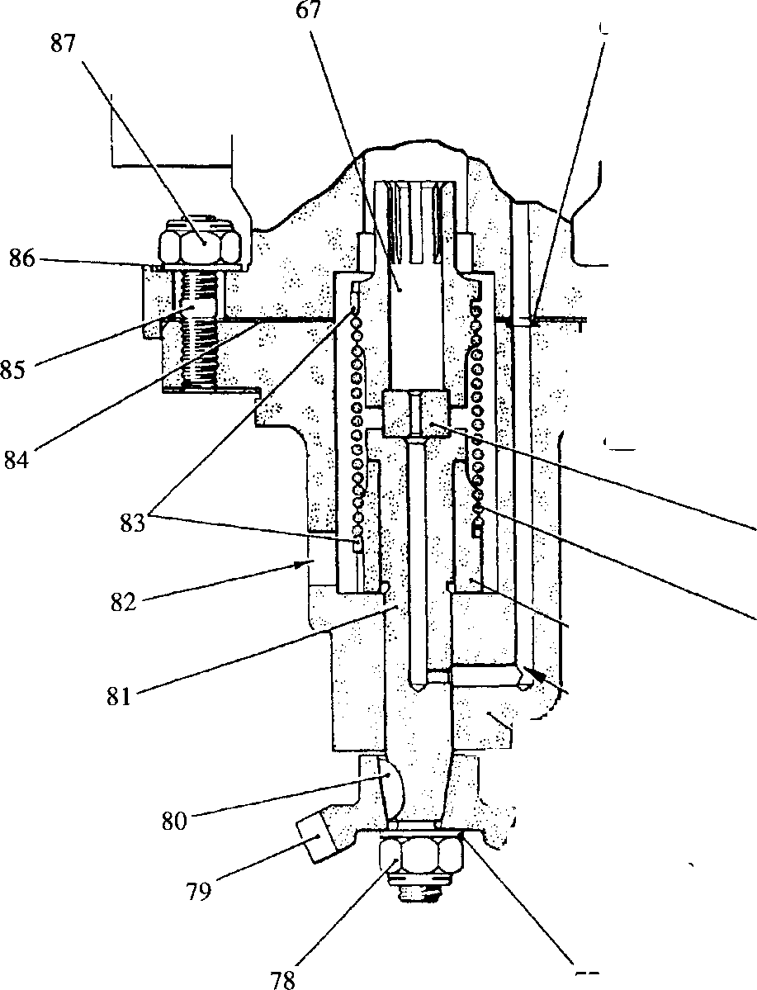

67

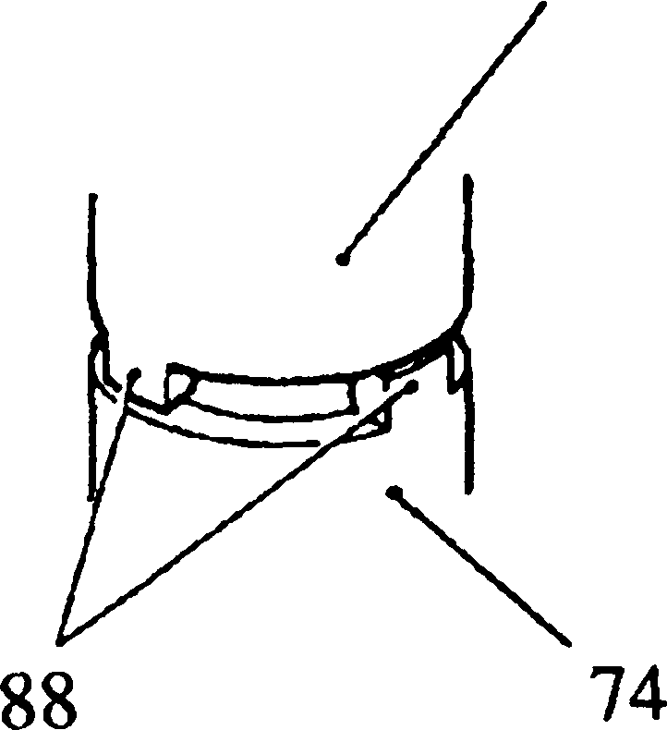

ORIVE DOG ARRANGEMENT

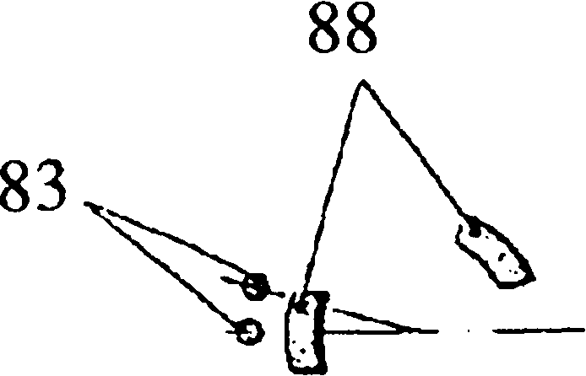

STATIC RELATIONSHIP OF DOGS AND SPRING TANGS

Key To Numbers

|  |  |  |  |
| --- | --- | --- | --- |
| 67. | Upper drive sleeve | 78. | Philidas nut |
| 68. | 'O' ring | 79. | Bevel gear |
| 69. | Overspeed trip unit | 80. | Key |
| 70. | Capscrew | 81. | Drive shaft |
| 71. | Shim | 82. | Oil drain port |
| 72. | Thrust bearing | 83. | Spring tangs |
| 73. | Drive spring | 84. | Joint |
| 74. | Lower drive sleeve | 85. | Stud |
| 75. | Oil drilling | 86. | Plain washer |
| 76. | Housing | 87. | Philidas nut |
| 77. | Plain washer | 88. | Drive dogs |

Fig HD.l Overspeed Trip Unit Drive

Key To Numbers

1. Domed head screw
2. Indicator button
3. Cap
4. Spring
5. Switch roller
6. Insulating leaf
7. Microswitches
8. Microswitch bracket
9. Cable gland
10. Diaphragm
11. Capscrew
12. Valve housing
13. Oil outlet port
14. Locknut
15. Indicator block
16. Non-return valve
17. Capscrew
18. Oil port
19. Plug
20. 'O' rings
21. Indicator valve
22. Centre bolt
23. Cap
24. Capscrew
25. Microswitch housing
26. Locknut
27. Cone
28. Indicator stem
29. Collar
30. Thrust race
31. Lower spring carrier
32. Nut
33. Peg
34. Locking wire
35. Locking nut
36. Outer adjusting screw
37. Collar
38. Circlip
39. Inner adjusting screw
40. Speeder spring
41. Top cover
42. Flyweight
43. Spindle
44. Bush
45. Pilot valve
46. Flyweight carrier
47. Dowel
48. Feedback land
49. Feedback chamber
50. Inlet port
51. Top land
52. Pilot valve drilling
53. Rotor
54. Body
55. Oil supply port
56. Circlip
57. Thrust collar
58. Oil drain port
59. Oil outlet port
60. Non-return valve
61. Joint
62. Oil drilling
63. Oil jet
64. Capscrew
65. Microswitch cover
66. Capscrew

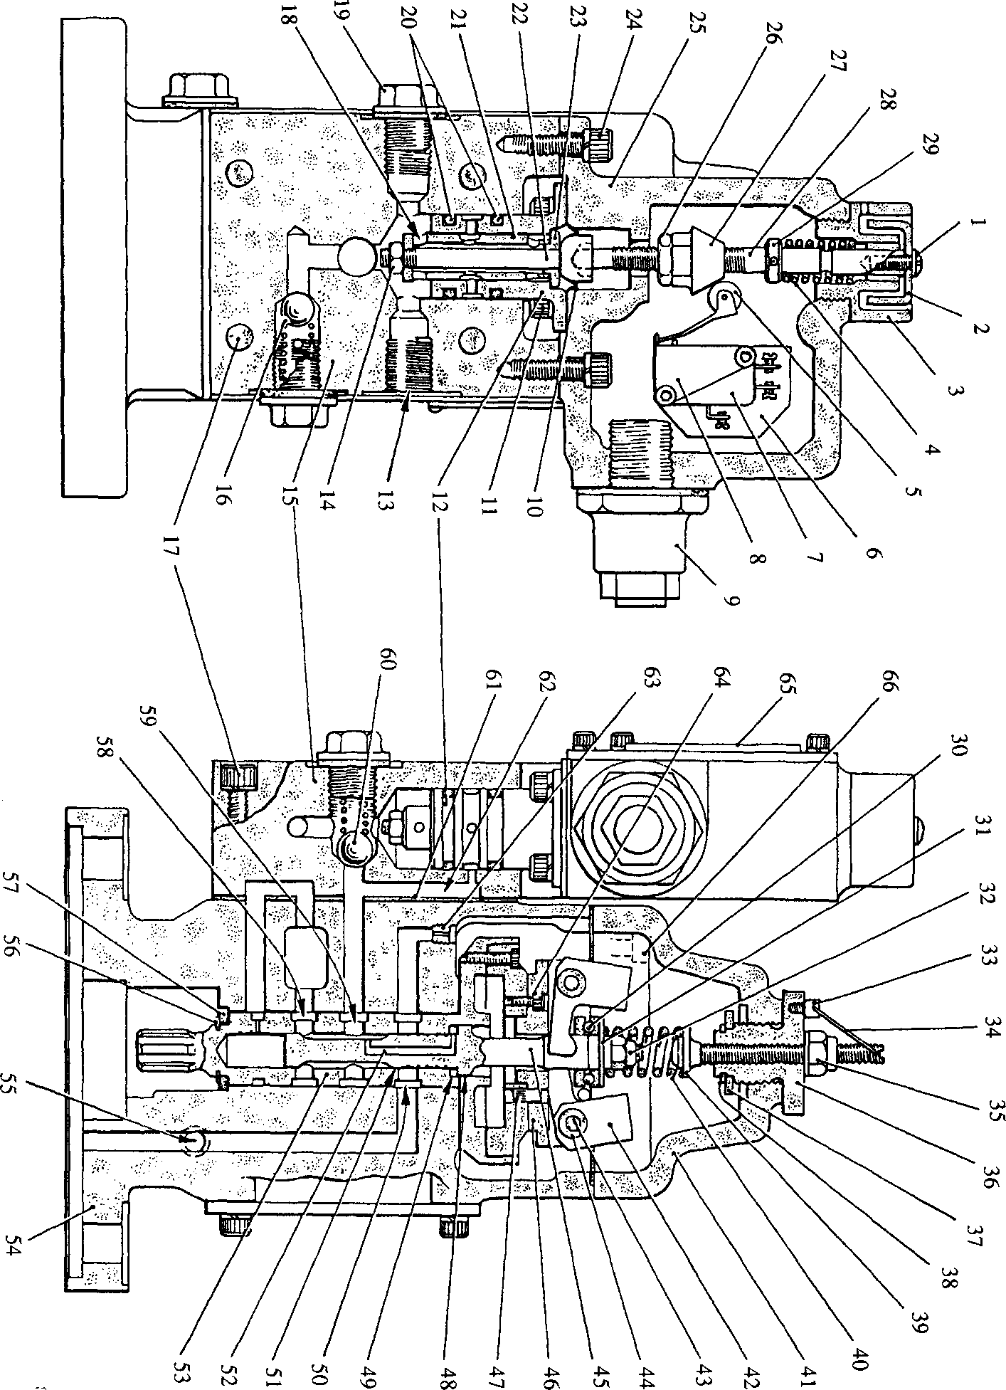

**SPD00331**